

**Developer and Publisher:**

Nintendo

**Intended Platforms:** Nintendo Entertainment System

**Projected Ship Date:** July 9, 1981

**Target Age:** Kids and Up

**Genre:** Platformer

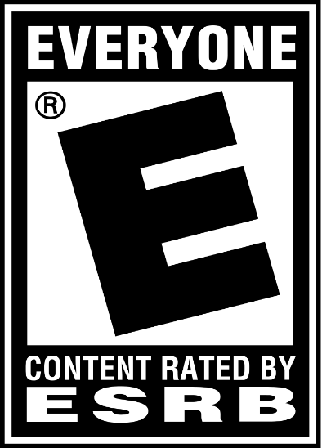

Table of Contents

Game Outline – Page 3

Characters – Page 4

Levels – Page 5

Enemies and Others – Page 6

UI and Interface – Page 7

Gameplay and Mechanics – Page 8

Monetization – Page 10

Game Outline

**Story:**

The game starts with a cutscene of Donkey Kong climbing up ladders in a construction site with Pauline in his clutches. He then sets down Pauline and starts stomping with it’s feet, causing steel beams to fall and change shape. Mario is now tasked with rescuing Pauline from the wrecked construction site and defeating Donkey Kong.

**Main Gameplay Objective:**

Rescue Pauline from Donkey Kong and venture through three different levels with scaling difficulty as you keep looping back to the beginning.

**Challenges:**

As Mario climbs his way up the construction site, there are many obstacles in the way such as rolling barrels, fireballs that follow Mario around, and a jumping Jack spring.

Characters

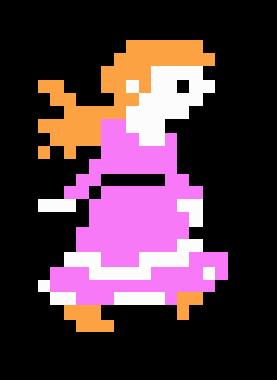Pauline:

The damsel in distress but also Mario’s lover. She’s held by Donkey Kong at the top the construction site where Mario has to rescue her.

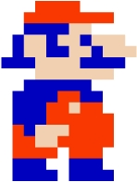Mario:

Mario is a carpenter and is the main protagonist of the game. He is able to jump over obstacles and smash down enemies with a hammer.

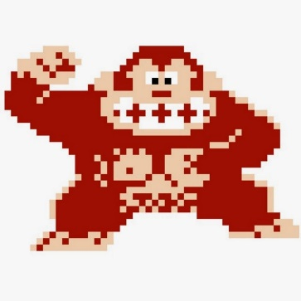

Donkey Kong:

The main antagonist of the game, he appears at the top of the construction site in every stage where he holds Pauline captive. He’ll be throwing obstacles at Mario, preventing him from climbing up!

Levels

There are three different levels, one for each Meter increment. (Except the 50M increment which is cut fro the NES port.

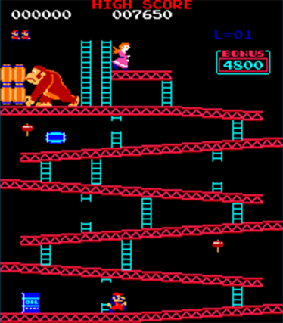25M (Girders):

This stage has seven levels of tilted girders which Donkey Kong was responsible for doing. Donkey Kong chucks barrels down from the top as you climb up to rescue Pauline. In the NES port instead of a blue barrel, the first normal one will ignite the oil can instead.

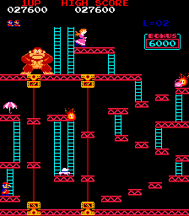75M (Elevators):

This stage has elevators on each side, the first one goes up and the second goes down. Instead of the usual vertical traversing, the player must jump across platforms in order to reach the area with stairs. Instead of the usual barrels, Donkey Kong throws out Jacks which all bounce and land in the same spots.

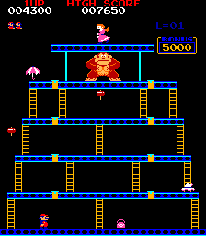100M (Rivets):

This is a vertical stage made up of blue, un-crooked girders this time. Instead of barrels, there are multiple fireballs that spawn as time progresses. There are yellow spots in the girders which Mario has to step on in order to make the construction site collapse.

Enemies and Others

Barrels:

Barrels will be thrown by Donkey Kong throughout the 25M levels. Blue barrels will create a fireball if they reach an oil drum.

Fireballs:

These little guys will follow Mario around the level. They can climb ladders and will only be defeated with a hammer! The bigger ones appears in 100M levels.

Cement Tub:

C:\_Projects\GameDev\VGTD\VGTD\DonkeyKong_CementTub.png

C:\_Projects\GameDev\VGTD\VGTD\DonkeyKong_Jack.pngJack:

These springs start to appear in 75M levels. They fall straight down from where Donkey

**Items**

Hammer:

C:\_Projects\GameDev\VGTD\VGTD\DonkeyKong_Hammer.pngHammers are able to defeat all enemies in the game (besides Donkey Kong of course). When Mario is swinging away with the hammer, he cannot jump or climb ladders unless the time expires.

Point Boosters:

The Parasol, Hat, and Purse all give the player 800 bonus points when they’re picked up.

UI and Interface

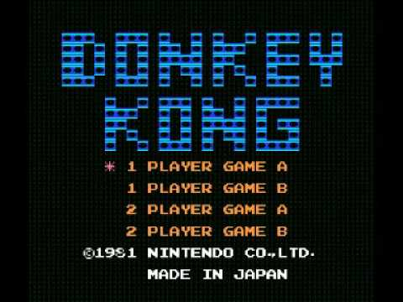

Menu:

The menu lets you select between 1 Player and 2 Player versions of Game-A and Game-B. Game-A starts off at a normal difficulty while Game-B is the accelerated, harder mode. (as if you looped levels a couple of times already)

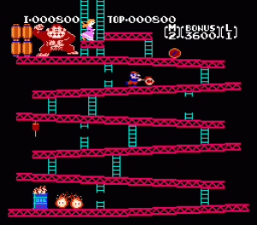

Game UI:

The game UI shows several scoring systems.

* I = Shows the current score
* TOP = Shows the high score
* M = Player 1’s lives
* Bonus = How many bonus points left that you can obtain
* L = Player 2’s lives

Gameplay and Mechanics

**Controls**

Donkey Kong™ is a one-player / two-player game set in a construction site. The players control Mario using a very simple control scheme. Left and Right on the NES D-pad to move, and A to jump.

**Game Modes**

The menu lets you select between 1 Player and 2 Player versions of Game-A and Game-B. Game-A starts off at a normal difficulty while Game-B is the accelerated, harder mode (as if you looped levels a couple of times already).

In the two-player mode, the second player will control the character Luigi instead, Mario’s brother.

**Interactions**

As players climb up construction sites there will be obstacles in the way. All enemies Mario touches will result in him losing a life. The barrel is an exception as you can either jump over it or grab a hammer and

**Looping Levels**

When you beat the 100M level you will loop back to the first level again. With each loop, difficulty also increases. Barrels will roll faster, fireballs will follow you faster, etc. One loop after Game A also brings you to Game B.

**Death and Game Overs**

When the player loses a life they start the stage over again from the beginning. In a two-player game however, the other player’s turn starts until they die.

When a player loses all of their lives they are removed from the game. When both players die, the game ends and the game over screen is shown.

**High Score**

At any point in the game, the player will replace the TOP Score if they manage to get a higher score.

Monetization

**Base Game Price:** $80